实验二 面向对象分析与类图设计（4学时）
课 程 | 面向对象分析与设计 | 实验项目 | 类图设计-2 | 成 绩
专业年级 | 软件工程2017 | 指导教师 | 王世元 | 实验日期 | 6.16
姓 名 | 陈东 | 学 号 | 201731062232
姓 名 | 沈瑞琦 | 学 号 | 201731062229
姓 名 | 刘平 | 学 号 | 201731062233
姓 名 | 卿梦成 | 学 号 | 201731062215
实验目的及要求：
目的：学会类图的绘制，学会利用面向对象的思想分析相关业务域问题。
要求：
- 学会绘制类图
- 深刻理解面向对象思想中的封装、继承、与多态
- 学会应用相关面向对象思想分析实际业务领域的问题
- 能够将面向对象分析的过程，编码加以具体实现，在实践中加深理解
说明：
- 光线跟踪算法（Ray Tracing Algorithm）是计算机图形学中非常重要的一个算法。该算法应用真实物理光照中的一些概念与思想，用计算机算法模拟的方法，用于生成一张真实感图片。在电影，动画，游戏，广告等工业领域都有重要应用。
- 该算法思想来源于模拟人眼看到物体时的场景，光线从光源发射出去，经过物体的各种反射，最终进入人眼，形成一幅图片。由于其算法特点短小而且符合人眼观察物体的物理特性，非常适合进行面向对象思想的分析与设计。
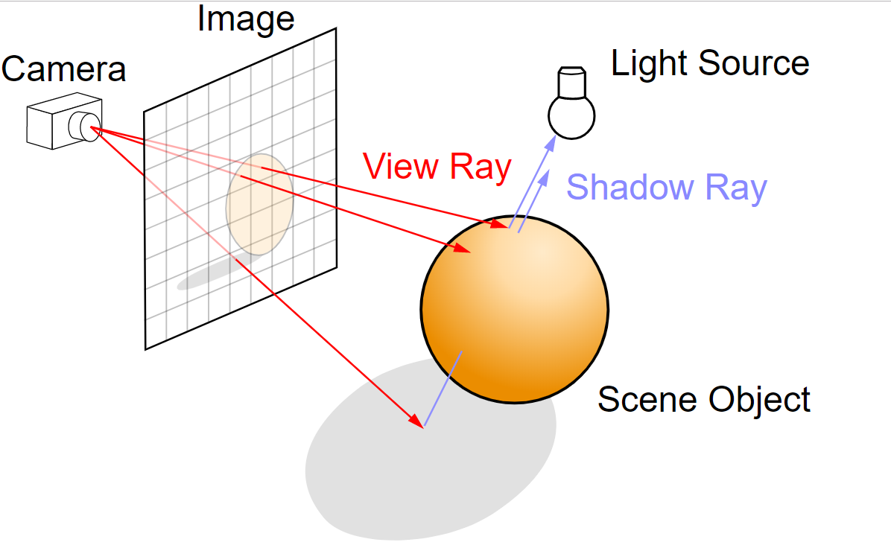
- C#中的Bitmap类，可以帮助你实现对应图片数据的生成，该类的SetPixel()方法，可以设置一张图片的每个像素的颜色值。利用该类，可以将最终图片显示在某个窗体上，或者存储成一张图片。
- 相关算法资料在附件中，请根据附件内容，完成如下实验报告。
- 相关网站：
- Smallpt: http://www.kevinbeason.com/smallpt/
- Ray tracing in one weekend: https://github.com/petershirley/raytracinginoneweekend

实验内容：
- 简要描述你准备编写的软件的基本功能
通过构建向量、光线、光强、图形对象，实现模拟人眼观看物体收到反射光的原理，将呈现视线在不同位置情况下的图形情况，可以使用2D图像绘制出3D效果。

- 你所实现的光线跟踪软件相关类图

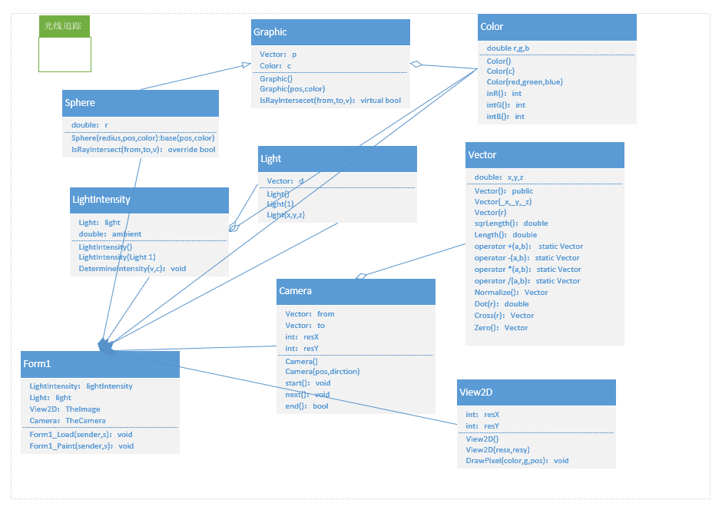

- 具体代码贴图以及软件功能展示截图
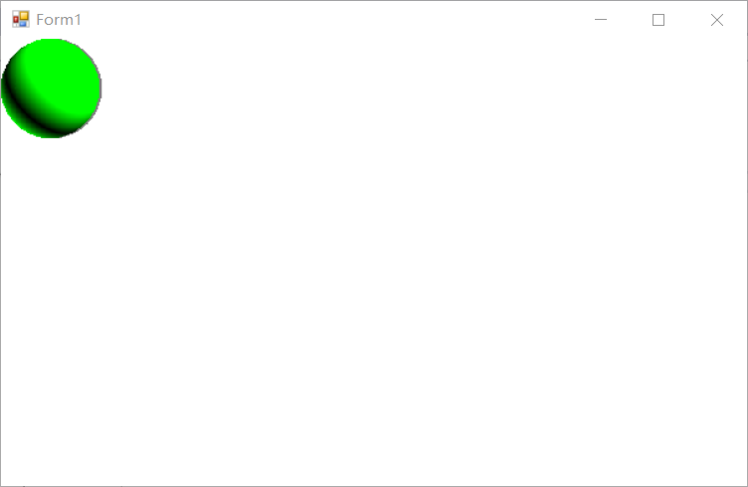

Camera.cs
using System;
using System.Collections.Generic;
using System.Linq;
using System.Text;
using System.Threading.Tasks;

namespace uml3
{
public class Camera
{
public Vector from;
public Vector to;
public int resX = 200;
public int resY = 200;

public Camera() { }
public Camera(Vector pos, Vector direction)
{
from = new Vector(pos);
to = new Vector(direction);
}
public void start()
{
from.x = -1.0;
from.y = -1.0;
}
public void next()
{
from.x += 2.0 / resX;
if(from.x >= 2.0)
{
from.x = -1.0;
from.y += 2.0 / resY;
}
}
public bool end()
{
return from.y < 3.0;
}
}
}

View2D.cs
using System;
using System.Collections.Generic;
using System.Drawing;
using System.Linq;
using System.Text;
using System.Threading.Tasks;

namespace uml3
{
public class View2D
{
public int resX;
public int resY;
public View2D() { }
public View2D(int resx, int resy)
{
resX = resx;
resY = resy;
}
public void DrawPixel(Color color, Graphics g, Vector pos)
{
int x = (int)((pos.x + 1.0) * (resX / 5));
int y = (int)((pos.y + 1.0) * (resY / 5));
g.DrawLine(new Pen(System.Drawing.Color.FromArgb((int)color.intR(), (int)color.intG(), (int)color.intB()), 1), (int)x, (int)y, (int)x + 1, (int)y);
}
}
}

Light.cs
using System;
using System.Collections.Generic;
using System.Linq;
using System.Text;
using System.Threading.Tasks;

namespace uml3
{
public class Light
{
public Vector d;
public Light() { }
public Light(Light l)
{
d = l.d;
}
public Light(double x, double y, double z)
{
d = new Vector(x, y, z);
d.Normalize();
}
}
}

LightIntersity.cs
using System;
using System.Collections.Generic;
using System.Linq;
using System.Text;
using System.Threading.Tasks;

namespace uml3
{
public class LightIntensity
{
Light light;
double ambient = 0.3;

public LightIntensity() { }
public LightIntensity(Light l)
{
light = l;
}
public void DetermineIntensity(Vector v, ref Color c)
{
c.g = (light.d * v) + ambient;
if (c.g < 0) c.g = -c.g;
c.r = c.b = 0.0;
}
}
}

Graphic.cs
using System;
using System.Collections.Generic;
using System.Linq;
using System.Text;
using System.Threading.Tasks;

namespace uml3
{
public class Graphic
{
protected Vector p;
protected Color c;
public Graphic()
{
p = new Vector();
c = new Color();
}
public Graphic(Vector pos, Color color)
{
p = new Vector(pos);
c = new Color(color);
}
public virtual bool IsRayIntersect(Vector from, Vector to, ref Vector v)
{
return true;
}
}
}

Vector.cs
using System;
using System.Collections.Generic;
using System.Linq;
using System.Text;
using System.Threading.Tasks;

namespace uml3
{
public class Vector
{
public double x, y, z;
public Vector()
{
x = y = z = 0.0;
}
public Vector(double _x, double _y, double _z)
{
x = _x; y = _y; z = _z;
}
public Vector(Vector r)
{
x = r.x; y = r.y; z = r.z;
}
public double sqrLength()
{
return x * x + y * y + z * z;
}
public double Length()
{
return Math.Sqrt(sqrLength());
}
public static Vector operator +(Vector a, Vector b)
{
return new Vector(a.x + b.x, a.y + b.y, a.z + b.z);
}
public static Vector operator -(Vector a, Vector b)
{
return new Vector(a.x - b.x, a.y - b.y, a.z - b.z);
}
public static Vector operator *(Vector a, double v)
{
return new Vector(a.x * v, a.y * v, a.z * v);
}
public static double operator *(Vector v1, Vector v2)
{
return v1.x * v2.x + v1.y * v2.y + v1.z * v2.z;
}
public static Vector operator /(Vector a, double v)
{
return new Vector(a.x / v, a.y / v, a.z / v);
}
public Vector Normalize()
{
double invlen = 1 / Length();
return this * invlen;
}
public double Dot(Vector r)
{
return x * r.x + y * r.y + z * r.z;
}
public Vector Cross(Vector r)
{
return new Vector(-z * r.y + y * r.z, z * r.x - x * r.z, -y * r.x + x * r.y);
}
public Vector Zero()
{
return new Vector(0, 0, 0);
}
}
}

Sphere.cs
using System;
using System.Collections.Generic;
using System.Linq;
using System.Text;
using System.Threading.Tasks;

namespace uml3
{
public class Sphere : Graphic
{
double r;
public Sphere(double radius, Vector pos, Color color) : base(pos, color)
{
r = radius;
}
public override bool IsRayIntersect(Vector from, Vector to, ref Vector v)
{
Vector vec = from - p;
double b = to * vec;
double c = vec * vec - r * r;
double d = b * b - c;
if (d < 0) return false;
double delta = Math.Sqrt(d);
double t = -b + delta;
if (t < 0) return false;
Vector v1 = to * t + from;
v1 = v1 - p;
v = v1.Normalize();
return true;
}
}
}

Color.cs
using System;
using System.Collections.Generic;
using System.Linq;
using System.Text;
using System.Threading.Tasks;

namespace uml3
{
public class Color
{
public double r, g, b;
public Color()
{
r = g = b = 0.0;
}
public Color(Color c)
{
r = c.r;
g = c.g;
b = c.b;
}
public Color(double red, double green, double blue)
{
r = red;
g = green;
b = blue;
}
public int intR()
{
int tmp = (int)(255 * r);
tmp = tmp > 255 ? 255 : tmp;
return tmp < 0 ? 0 : tmp;
}
public int intG()
{
int tmp = (int)(255 * g);
tmp = tmp > 255 ? 255 : tmp;
return tmp < 0 ? 0 : tmp;
}
public int intB()
{
int tmp = (int)(255 * b);
tmp = tmp > 255 ? 255 : tmp;
return tmp < 0 ? 0 : tmp;
}
}
}

Form1.cs

using System;
using System.Collections.Generic;
using System.ComponentModel;
using System.Data;
using System.Drawing;
using System.Linq;
using System.Text;
using System.Threading.Tasks;
using System.Windows.Forms;

namespace uml3
{
public partial class Form1 : Form
{
public Form1()
{
InitializeComponent();
}

LightIntensity lightIntensity = null;
Light light = null;
View2D TheImage = null;
Camera TheCamera = null;

private void Form1_Load(object sender, EventArgs e)
{
this.Paint += new PaintEventHandler(this.Form1_Paint);
}

private void Form1_Paint(object sender, PaintEventArgs e)
{
Graphics g = e.Graphics;
g.FillRectangle(Brushes.White, ClientRectangle);

Vector p1 = new Vector(0.0, 0.0, 0.0);
Color c1 = new Color(0.0, 0.4, 0.2);
Sphere s1 = new Sphere(0.5, p1, c1);

Vector p2 = new Vector(0.5, 0.5, -1.0);
Color c2 = new Color(0.0, 0.5, 0.0);
Sphere s2 = new Sphere(0.7, p2, c2);

light = new Light(1.0, -1.0, -1.0);
lightIntensity = new LightIntensity(light);

Vector from = new Vector(0.0, 0.0, 3.0);
Vector to = new Vector(0.0, 0.0, -1.0);
TheCamera = new Camera(from, to);

TheImage = new View2D(TheCamera.resX, TheCamera.resY);
Color bgcolor = new Color(0.5, 0.5, 0.5);

Vector v = new Vector();
Color color = new Color();

for (TheCamera.start(); TheCamera.end(); TheCamera.next())
{

if (s1.IsRayIntersect(TheCamera.from, TheCamera.to, ref v))
{
lightIntensity.DetermineIntensity(v, ref color);
TheImage.DrawPixel(color, g, v);
}
else TheImage.DrawPixel(bgcolor, g, v);
}
}
}
}

